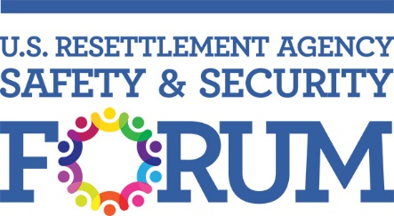

***Disclaimer:*** *while agencies are ultimately responsible for their own decisions on safety/security matters, the guidance within this document is offered as a resource to promote awareness of good safety and security practices pertaining to Duty of Care. The information offered here is in no way intended as legal advice that agencies rely upon as justification for its actions. For advice and guidance on specific matters, please consult a relevant expert, such as an attorney or safety and security expert.*

# TEMPLATE

**BOARD/LEADERSHIP RESOLUTION DUTY OF CARE STATEMENT**

**Whereas** for humanitarian organizations, the Duty of Care (DoC) is a moral and legal obligation to ensure that risks to personnel are identified and managed, and that personnel receive the support, resources, information and training they need to reduce the risks to which they are exposed.

**Whereas** many aid organizations’ senior management are investing more time and resources to review and improve their security risk management systems and processes, including the development of Duty of Care statements.

**Whereas** the legal duty of care is defined as the obligation imposed on an individual or organization by law requiring that they adhere to a standard of reasonable care while performing acts (or omissions) that present a reasonably foreseeable risk of harm to others.

**Whereas** there is also an ethical or moral duty to ensure the well-being of individual(s) affected by the organization’s activities,

# NOW, THEREFORE, BE IT:

**RESOLVED,** upon resolution made and passed, the Duty of Care Statement shall be as follows:

has a moral and legal Duty of Care (DoC) to ensure that reasonably foreseeable safety and security risks to staff and associated personnel1 are identified; that staff and personnel are informed of and voluntarily consent to assume such risks; and, where they do, they receive the needed support, resources, information, and training to reasonably mitigate the risks to which they are exposed on behalf of .

# Secretary’s Certification:

It is hereby certified by the undersigned that the foregoing resolution was duly approved at a meeting of the Board of Directors/Leadership of , duly called and held on date time and location and the foregoing resolutions have been duly recorded in the meeting minutes of the Board and are in full force and effect.

Secretary and Treasurer or authorized designee

Date:

1 Staff and associated personnel include all

interns and volunteers or others working on behalf of

employees, board members, consultants, contractors, fellows, in any global location or on behalf of

patriate staff.

in a non-

location. The term also includes, for this purpose, immediate family members of ex-